**Dynamic Simulation of Autonomous Underwater Vehicles**

Employing Dynamic Simulation To Model And Optimize The Operation Of Autonomous Underwater Vehicles For Ocean Exploration

# **Abstract**

The utilization of autonomous underwater vehicles (AUVs) has become extensive due to the expanding scope of activities conducted in the deep sea. Underwater activities such as environmental monitoring, oceanographic research, and undersea exploration rely heavily on AUVs. Accurately predicting the dynamic behaviour of these vehicles with sophisticated modelling techniques is necessary to ensure their efficiency and dependability. A dynamic model of an AUV operating underwater with possible obstacles has been described here. AUV dynamics, hydrodynamic modeling, six degrees of freedom dynamics, algorithms, and environmental interactions are all encompassed in this paper's extensive dynamic simulation model. The suggested model makes it easier to build and test control techniques as well as analyse and optimise AUV performance under various operating situations. The simulation framework advances underwater robotics and expands the possibilities of autonomous underwater systems by offering a thorough grasp of AUV dynamics.

# **Introduction**

Problem Statement:

Autonomous underwater vehicles (AUVs) are untethered unmanned robotic platforms that can be preprogrammed to achieve accurate navigation, control, and guidance tasks. These have been in development in recent decades to address the high cost of underwater exploration. An example of underwater robotics development for oceanography research can be found with the Seaglider, where the AUV is designed to operate for long periods of time to gather ocean data at a fraction of the cost of manned expeditions.

Though research in underwater robotics and AUVs has greatly progressed, the sensors and equipment required for accurate navigation and reliable operation in underwater environments often come at high costs. The dynamic underwater environment also hosts a set of new challenges, ranging from navigation where GPS does not function to environments of operation prone to unpredictable disturbances.

Without any humans in the loop, these vehicles must be able to execute complex missions correctly and handle unexpected scenarios (e.g., faults, obstacle avoidance, low batteries, etc). In addition, these vehicles must be rugged and reliable electrically and mechanically to accomplish the missions successfully. Unlike terrestrial and space environments, the underwater domain typically imposes the most restrictive physical control and sensor limitations upon any AUV (e.g., corrosion, leaks, ground faults, acoustic variability).

Research Question:

What are the factors that might be affecting the motion of the Autonomous Underwater Vehicle and how can these factors be handled in a way that the operation of the AUV is optimized in a dynamic underwater environment?

Main Objective:

Formulating a dynamic mathematic model for the AUV based on a combination of theory and empirical data that provides an efficient platform for control system development

Specific Objectives:

1. Research on areas such as vehicle (carrier/platform) design, architecture, motion control, intelligent planning and decision-making, etc.
2. Developing a model that is able to explore deep-sea areas that are extremely difficult for humans to reach.
3. Working on the underwater dynamics of the AUV that control its motion.
4. To establish the forces that govern the motion of the AUV and work on their mathematical equations.

Methods:

Although there now exist many remotely operated submersibles (ROVs) and a matured field of autonomous robot research, only a few AUVs exist and their capabilities are still limited, albeit extending. Difficult, tedious, and potentially hazardous at-sea testing provides technical challenges to directly observe the AUV in situ; environmental restrictions and the unacceptable loss of an AUV due to tremendous investment in time and resources are all reasons for justifying the use of modeling and simulation for AUV development, testing, and personnel training so that component and system-level troubleshooting and mission planning can be carried out more cost-effectively.

As AUVs typically operate underwater, the effects of waves and currents on the vehicle motion are greatly reduced, thus, providing the required stability for a suite of sensors onboard, such as imaging sonars. Further mission enhancement could involve multiple small AUVs deployed with long-endurance, adaptive, cooperative capabilities such that the sampling objective can be achieved by means of “divide and conquer.”

These goals can be achieved through the improvement of maneuvering precision and motion control capability with energy constraints. For low energy consumption, low resistance, and excellent maneuverability, fins are usually used to modify AUV hydrodynamic force. The AUV with fins can do gyratory motion by vertical fins and do diving and rising motion by horizontal fins, allowing for improved performance in various underwater environments.

A dynamic mathematic model for the AUV based on a combination of theory and empirical data would provide an efficient platform for control system development. Although some modeling and simulation methods have been proposed and applied, there is no standard procedure for modeling the AUV in industry. Therefore, the modeling and simulation of the AUV with fins is a challenge.

Thus an AUV, without fins, has been visualized here and a model has been generated which aims to analyze the behavior and performance of the AUV underwater. The concepts of Six Degree of Freedom and Hydrodynamic Modeling have been applied to enhance navigation and control systems.

# 

# **Literature Review**

The paper "Dynamic Modeling and Computer Simulation for Autonomous Underwater Vehicles with Fins" by X. Liang et al. (2013) provides a comprehensive analysis of the dynamic modeling and control of autonomous underwater vehicles (AUVs) that are equipped with fins. The paper's focus on WL-II mini-AUV, a small, low-cost platform used in various oceanographic applications, exemplifies the use of the developed model in practical scenarios. The key contributions and findings outlined in the initial sections of the paper are as follows:

1. Introduction to AUVs with Fins: The paper begins by emphasizing the increasing application of AUVs in deep-sea activities and underscores the need for fins on these vehicles to improve their motion control and maneuverability. The AUVs' ability to perform gyratory motions through vertical fins and diving and rising motions through horizontal fins is highlighted.
2. Challenges in Modeling AUVs with Fins: The authors discuss the importance of an accurate dynamic mathematical model based on theory and empirical data to facilitate the development of efficient control systems. Nevertheless, they point out that there is a lack of standard procedures in the industry for modeling AUVs with fins, making this area particularly challenging.
3. Model Development and Verification: The paper describes the development of a six-degree-of-freedom (DOF), non-linear model for AUVs with fins. This model takes into account various forces and moments resulting from hydrostatics, hydrodynamic lift and drag, added mass, and the influence of thrusters and fins. The equations describing the rigid-body dynamics are in non-linear form to closely mimic the inherently non-linear behavior of the AUVs.
4. Simulation and Comparison with Real Data: To validate the model, motion simulation is carried out through numerical integration of the motion equations. The simulation output is then checked against AUV dynamics data collected from real sea experiments. The results show that the non-linear model provides an accurate estimation of the actual motion of the AUV.

The paper highlights that the non-linear model provides an accurate representation of the AUV's actual motion, suggesting that it could be a feasible and reliable approach for AUV motion control system development. The paper suggests that this improved modeling can facilitate advancements in modularization, cost reduction, and maneuvering precision of AUVs, aiding their applications in long-range oceanographic surveying, autonomous docking, and mine countermeasures in shallow water.

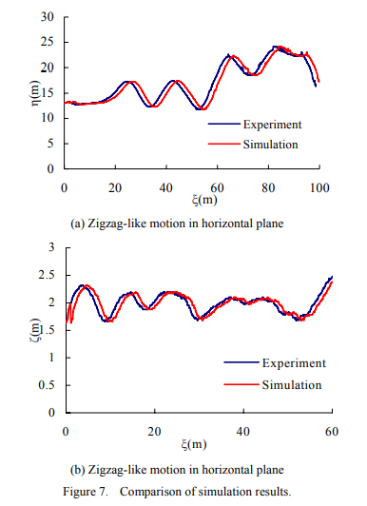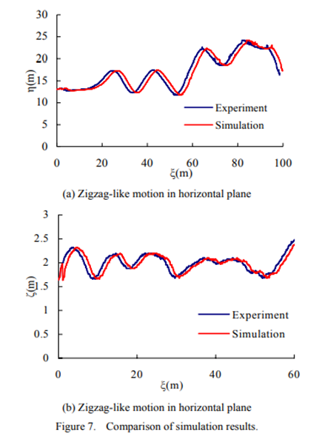

The paper "Autonomous Underwater Vehicles Support for Enhanced Performance in the Internet of Underwater Things" by Manal Al-Bzoor et al. (2019) addresses the challenges faced by the Internet of Underwater Things (IoUT), which is primarily dependent on underwater acoustic wireless sensor networks (UASN). The IoUT was initially proposed to help with real-time monitoring and exploration of underwater environments and is now crucial for developing and connecting future underwater smart cities.

1. Introduction to Multi-AUV Path Planning: Previous research has addressed path planning for single autonomous underwater vehicles (AUVs). However, as the complexity of underwater missions increases, there is a growing interest in coordinating multiple AUVs for cooperative tasks. Cooperative path planning aims to optimize the trajectories of multiple AUVs to achieve collective objectives efficiently while considering dynamic ocean conditions.
2. Challenges: One of the main challenges is that acoustic waves, the primary means of underwater communication, suffer from long propagation delays and high transmission energy demands. To overcome these issues, the authors propose utilizing autonomous underwater vehicles (AUVs) for data collection and incorporating a cluster-based routing approach. In particular, a smart genetic-based AUV path planning algorithm is presented, which is designed to enhance the performance of UASN.
3. Modeling Data Collection method: The paper integrates the smart data collection method with a dynamic location-unaware clustering algorithm that considers mobility to reduce energy consumption further. The simulation results demonstrate that the proposed genetic-based technique significantly increases network lifetime by more than 145% and decreases energy expenditure by nearly 75% compared to the traditional diagonal path selection technique.
4. Functionality of model: Additionally, when comparing their combined technique to a novel clustering method, the authors found that their approach doubles the network lifetime, reduces total energy consumption by almost 30%, and increases the delivery ratio by 15% at lower densities.

Overall, the paper contributes to the field by offering a method that potentially extends the functionality and lifetime of UASN, which is vital for the success of the IoUT, especially in the context of developing underwater smart cities. The research seeks to advance the capabilities of AUVs for collaborative tasks and enhance their effectiveness in real-world applications.

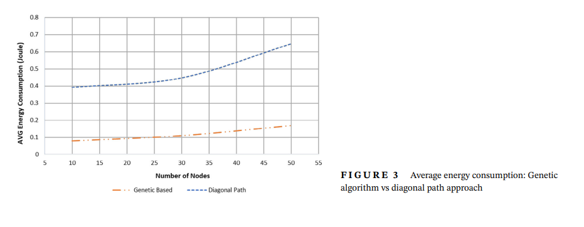

The research paper "Cooperative Path Planning of Multiple Autonomous Underwater Vehicles Operating in Dynamic Ocean Environment" by Yufei Zhuang et al. (2019) discusses a two-stage algorithm for cooperative path planning of multiple autonomous underwater vehicles (AUVs). The paper primarily focuses on achieving collision-free paths, minimum time consumption, and simultaneous arrival of AUVs operating in dynamic ocean environments, where both static and unexpected dynamic obstacles may be present.

1. Introduction to AUVs: Autonomous underwater vehicles (AUVs) are capable of performing underwater tasks autonomously with onboard navigation, guidance, and control systems. Developing advanced guidance systems or path planning techniques is critical for improving AUV autonomy and operational efficiency.
2. Problem Formulation: The paper formulates the problem by defining mathematical models that describe the motion of AUVs within a horizontal plane. With assumptions noted from previous research, the paper details dynamic and kinematic equations of motion for AUVs, considering forces such as damping coefficients and system inertia.
3. Cooperative Path Planning Algorithm: The authors propose a cooperative path planning algorithm for managing multiple AUVs. It accounts for both static and dynamic obstacles by utilizing a global Legendre pseudospectral method for static scenarios, which ensures optimal paths for collision avoidance and time efficiency. An adaptive intermediate knots insertion algorithm is introduced for segments between control nodes to keep multiple AUVs safe from collisions.
4. Local Re-planning Strategy for Dynamic Obstacles: For unexpected dynamic obstacles, the paper presents a local re-planning strategy involving two consecutive avoidance maneuvers. Utilizing the differential flatness property of AUVs enables fast reactions to dodge moving obstacles.
5. Simulation Results: The fourth section of the paper demonstrates simulation results to validate the proposed algorithm, although specific results are not detailed in the provided chunks. The simulation would show the algorithm's effectiveness in achieving the set goals.
6. Conclusions and Future Work: The paper concludes with insights into the effectiveness of the proposed algorithm and its potential applicability to other types of unmanned vehicles, like unmanned surface vehicles and unmanned aerial vehicles, with appropriate modifications.

The need for efficient path planning for AUVs in dynamic environments is established, and the authors situate their contribution in context with existing work and technological demands.

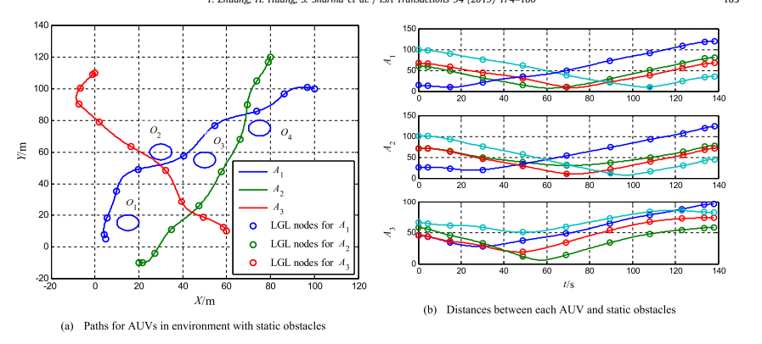

The paper "Control for Dynamic Positioning and Way-point Tracking of Underactuated Autonomous Underwater Vehicles Using Sliding Mode Control" by Taha Elmokadem et al. (2018) focuses on the development of robust control schemes for Autonomous Underwater Vehicles (AUVs). The control schemes aim to enable dynamic positioning and way-point tracking of these underactuated vehicles, which pose significant challenges due to their dynamics, uncertainties, and environmental disturbances.

The paper begins by highlighting the rising importance of AUVs in various fields such as ocean exploration, scientific research, and military missions. AUVs are capable of self-propulsion underwater and on the water's surface and are required to perform complex tasks automatically, often under unknown sea current conditions and variable loads.

1. Challenges: These include the complexity of vehicle dynamics, nonlinear characteristics, unmodeled dynamic effects, system uncertainties, and environmental disturbances. Underactuation, where there are fewer control inputs than degrees of freedom, adds to these challenges. The review sums up the motivations behind the work due to these design obstacles and the significant potential applications of AUVs.
2. Control Objectives for AUVs: These include trajectory tracking, path following, dynamic positioning, and way-point tracking. The paper compiles a variety of research works that approached AUV control problems using different strategies, including the ones mentioned above. It also labels the dynamic positioning problem as a mission to reach and maintain a vehicle at a desired stationary point, while way-point tracking involves tracking a series of points to reach a final destination.
3. Techniques used priorly: These are sliding mode control, adaptive control, higher-order sliding modes, learning control, neural network control, fuzzy control, and Lyapunov-based techniques. These methodologies are associated with different control challenges, such as trajectory tracking, path following, and combined control designs.
4. Robustness Scheme: The paper adopts the sliding mode control technique, which is known for its effectiveness in handling uncertainties and disturbances. The paper promises to deliver simulation results to validate the proposed controllers and to evaluate their robustness against model uncertainties and varying types of disturbances, including unknown currents.

In sum, the paper establishes the significance and difficulty of controlling AUVs, the wide range of applications they find use in, and the variety of control strategies that have been previously examined. It sets the stage for introducing and validating the sliding mode control-based approach that this paper focuses on.

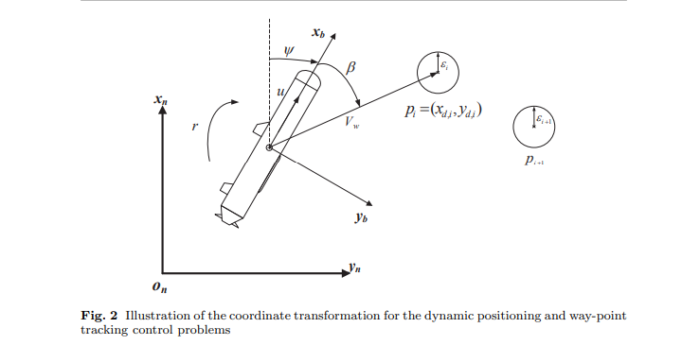

The paper titled "A Pso-Enhanced Gauss Pseudospectral Method To Solve Trajectory Planning For Autonomous Underwater Vehicles" by Wenyang Gan, Lixia Su, and Zhenzhong Chu focuses on a fast optimization method to address the trajectory optimization for autonomous underwater vehicles (AUVs) with an obstacle-avoidance navigation objective. It introduces a methodology combining the Gauss pseudospectral method (GPM) with particle swarm optimization (PSO) to overcome certain limitations in traditional trajectory planning.

1. Path Planning vs. Trajectory Planning: Differentiating between path planning, which yields a series of way-points, and trajectory planning, which includes time information corresponding to states.
2. Simultaneous Planning and Control (SPC) Method: Mention of a novel SPC method that combines an improved artificial potential field (IAPF) with model predictive control (MPC) for robust and efficient tracking.
3. Swarm Intelligence Algorithms: Discussion about an optimal control problem establishment for carrier aircraft trajectory on deck and the innovative segmented fitness function for efficient search.
4. Dynamic Measurement Heuristic A* Algorithm: Improvement of the classic A* algorithm for better search efficiency.
5. Optimization Methods: Investigation of algorithms that optimize convergence speed and solution quality through methods such as updating pheromone-based linear regression.
6. Ocean Current Disturbance Function: Incorporation into deep reinforcement learning algorithms to reduce path planning delay times.

The authors also review the uses of trajectory planning theory in various other fields, implying that this technique is not confined to underwater applications alone. They cite examples of its application in aircraft, robotic arms, and autonomous driving. Specifically, the authors underline how the adaptation of pseudospectral methods such as the iterative strategy based on initial values generator and the GPM for planning overtaking trajectories has been used in other fields to improve solution efficiency and manage trajectory control.

The central contribution of this paper, as laid out, is the proposal of combining PSO pre-planning with GPM as a method to enhance the initial values for the Sequential Quadratic Programming (SQP) algorithm used in solving the non-linear programming (NLP) problem. This methodology is posited to improve computational efficiency significantly, compared to other methods such as linear and cubic spline interpolation, by fitting pre-planned trajectory points on the Legendre-Gauss points of the GPM.

The review sets the stage for their proposed PSO-GPM method, which suggests a notable advance in solving the trajectory planning problem for AUVs, with implications for improved efficiency and effectiveness in facing the challenges of complex underwater environments.

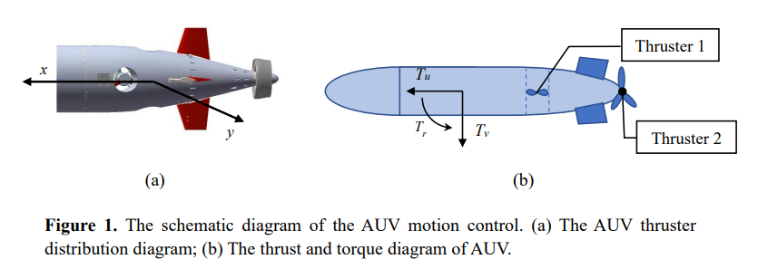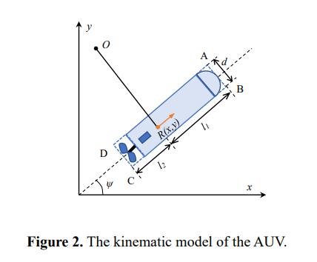

The paper titled “Design and Characteristic Analysis of Variable Buoyancy System for Long Range Autonomous Underwater Vehicle”, by Zhaoyang SUN, Jiancheng Yu, Yan Huang Zhenyu Wang, and Aiqun Zhang discuss the significance of Variable Buoyancy Systems (VBS) for enhancing the capabilities of long-range Autonomous Underwater Vehicles (AUVs).

1. Introduction to VBS: VBS plays a crucial role in adjusting buoyancy dynamically to counteract changes in environmental density, facilitating near-neutral buoyancy navigation and unpowered submerging and floating. Key factors for efficient buoyancy control include the accuracy of the AUV's pitching angle change model and the uniformity of hydraulic oil flow, which directly impacts power consumption during buoyancy adjustment.
2. Importance: Buoyancy adjustment serves as an alternative to propellers for AUV floating and submerging, thereby reducing propeller energy consumption. Maintaining a zero angle of attack during navigation minimizes resistance, enhancing endurance. AUV buoyancy is affected by factors such as seawater density variations during navigation, depth-related density changes, and compressive deformation in deep-sea conditions, necessitating precise buoyancy control and center of gravity adjustment.
3. Importance of VBS: Two common VBS methods involve changing volume or masses, with the former typically adopted for small underwater vehicles. This includes altering the displacement volume of external oil bladders by redistributing hydraulic oil or controlling piston stroke. Ensuring uniform flow stability during oil entry or exhaust under different pressures is crucial for efficient buoyancy control and reduced power consumption.
4. Objectives: Methods for improving endurance include increasing energy-carrying capacity, reducing energy consumption through subsystem efficiency improvements, and minimizing navigation resistance via precise pitch angle control.

The paper outlines the VBS design scheme, flow test results, AUV response modeling to buoyancy control, and depth-fixed navigation experiments. Through analysis, experimental testing, and theoretical calculation, the study emphasizes the importance of hydraulic oil flow uniformity, accurate modeling of AUV response to buoyancy adjustment, and the combined use of buoyancy and pitch control for achieving near-neutral buoyancy and zero-angle-of-attack navigation.

In conclusion, the study underscores the significance of uniform hydraulic oil flow for efficient buoyancy control, provides a refined model for describing AUV attitude changes, and demonstrates the effectiveness of combined buoyancy and pitch control in enhancing AUV navigation capabilities and endurance.

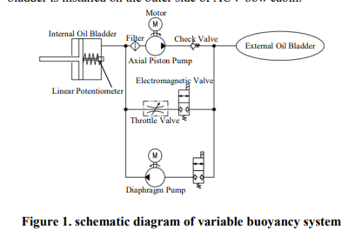

The paper, “Adaptive Attitude Control of Autonomous Underwater Vehicles Using Back-stepping”, by Yuqian Liu, Jiaxing Che, Hongli Xu, and Chengyu Cao, focuses on the design of an attitude controller for an advanced Autonomous Underwater Vehicle (AUV) prototype, utilizing a back-stepping control strategy.

1. Work Done in this Field: Previous publications have detailed the design of the AUV, which is propelled by four water pumps, along with presenting its nonlinear kinematic and dynamic model. The controller is designed to address dynamic uncertainties arising from external disturbances and actuator dynamics. Given the strict feedback form of the kinematics and dynamics of the attitude problem, the back-stepping control strategy is deemed suitable for handling this type of challenge. However, due to the propulsion method, only two angle channels of attitude are controllable, while the self-stability of the roll angle channel is ensured by the physical design and validated through experimentation.
2. Problem Formulation: This revolves around the limitations of the propulsion system, which can only control two angle channels. The stability of the uncontrollable roll angle channel has been validated experimentally. The objective is to design an attitude controller that enables pitch and yaw angle tracking of desired commands. The paper presents a reorganized system formulation for pitch and yaw angles, emphasizing the design objective of achieving desired attitude control.
3. Simulation and Comparison with Result: The performance of the attitude controller design, with parameters closely resembling those of the prototype. The allocation matrix transforms the control signal generated by the attitude controller into actuator commands, enabling the distribution of desired moments commands into RMP commands for each pump. Simulation results validate the efficacy of the attitude controller design.

In conclusion, the paper presents an attitude controller design for a low-cost AUV propelled by four water pumps. The simplified dynamic model facilitates control system design, with the back-stepping control theory employed for attitude control. Simulation results validate the performance of the controller, suggesting future work involving the introduction of advanced adaptive control strategies to further enhance attitude control capabilities.

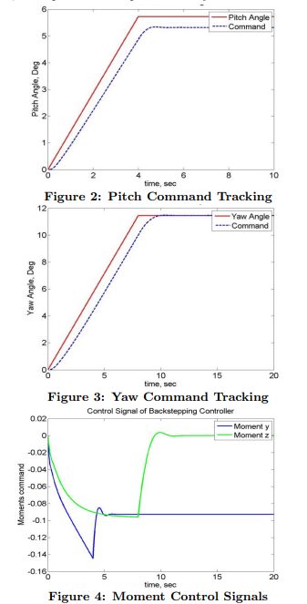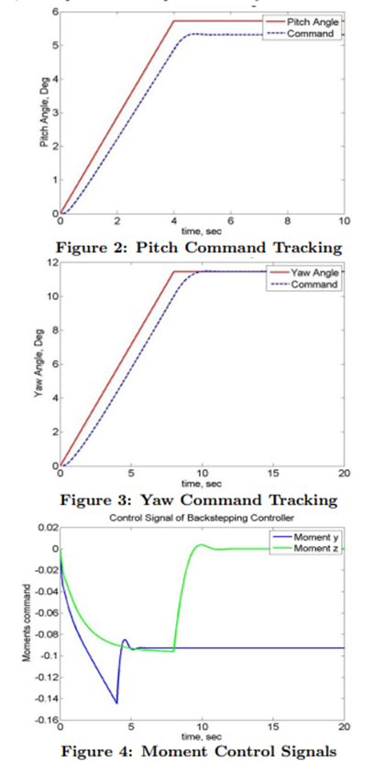

“Trajectory Planning of Autonomous Underwater Vehicles Based on Gauss Pseudospectral Method” by [Wenyang Gan](https://sciprofiles.com/profile/author/YUd4V0J1M0Q4MjkvY25nbjBYeHN3NHJrK0FhZThOcDFISXNMb1hnQTN2Zz0=?utm_source=mdpi.com&utm_medium=website&utm_campaign=avatar_name), [Lixia Su](https://sciprofiles.com/profile/2742119?utm_source=mdpi.com&utm_medium=website&utm_campaign=avatar_name), and [Zhenzhong Chu](https://sciprofiles.com/profile/2748241?utm_source=mdpi.com&utm_medium=website&utm_campaign=avatar_name) addresses the trajectory planning problem of autonomous underwater vehicles (AUVs) in complex environments, focusing on achieving obstacle avoidance while minimizing energy consumption and sailing time.

1. Introduction of Trajectory Planning method: It introduces a trajectory planning method based on the Gauss pseudospectral method (GPM) and establishes a multi-constraint trajectory planning model considering kinematics and dynamics constraints along with obstacle avoidance requirements.
2. Model Development: The optimal control problem is transformed into a nonlinear programming problem using the GPM, and the trajectory satisfying the optimization objectives is obtained by solving it with a sequential quadratic programming (SQP) algorithm. To enhance optimization, the paper proposes the use of cubic spline interpolation for generating initial values, which is shown to improve solution rapidity compared to linear fitting methods.
3. Trajectory Optimization Transformation: While trajectory planning research is well-developed in other fields such as aircraft and unmanned aerial vehicles, the exploration in AUV trajectory planning is still in its early stages. Traditional methods for trajectory optimization transformation include indirect and direct methods, with direct methods like the pseudospectral method gaining attention due to their ability to handle nonlinear optimal control problems effectively.

Among direct methods, the Gauss pseudospectral method (GPM) is particularly emphasized for its accuracy and convergence speed. It has been applied in various optimization problems, including trajectory planning for different systems like variable-wing aircraft and unmanned electric shovels. However, in the context of underwater vehicles, existing trajectory planning methods often neglect dynamic characteristics and constraints, hindering real optimization and tracking of planned trajectories.

1. Parameter Optimization: This involved algorithms like the sequential quadratic programming (SQP) algorithm or Pontryagin’s method, with the Gauss Pseudospectral Optimization Software (GPOPS) being a widely used tool.

The paper proposes enhancing the initial value generation process for trajectory planning using cubic spline interpolation, which proves to be more efficient than traditional linear fitting methods. Simulation results demonstrate the effectiveness of this approach, showing improved solution speed and smoother trajectories, validating the applicability of the GPM in AUV trajectory planning applications.

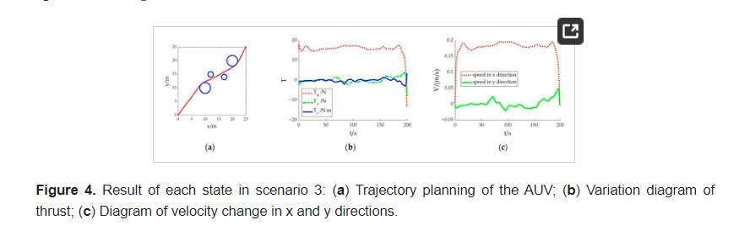

The paper by Tian et al. (2022) titled "Thruster Fault Diagnostics and Fault Tolerant Control for Autonomous Underwater Vehicle with Ocean Currents" focuses on the development and implementation of a method for thruster fault diagnostics and fault-tolerant control in autonomous underwater vehicles (AUVs) operating in the presence of ocean currents. The study utilizes simulation and underwater experiments to validate the proposed approach, emphasizing the importance of ensuring the accuracy and feasibility of thruster fault management strategies in AUVs (Tian et al., 2022).

1. Usage of Existing Work: The research builds upon existing literature related to fault-tolerant control in underwater vehicles. Zhang et al. (2015) introduced an adaptive terminal sliding mode-based thruster fault-tolerant control method for underwater vehicles in time-varying ocean currents, highlighting the significance of adaptive control strategies in fault management (Zhang et al., 2015). Similarly, Qin et al. (2019) investigated prescribed performance fault-tolerant trajectory tracking control for ocean bottom flying nodes, considering uncertainties, disturbances, and thruster faults, showcasing the relevance of fault-tolerant control methods in challenging underwater environments (Qin et al., 2019).
2. Important Discussed Aspects: Moreover, the study aligns with the broader context of fault diagnosis and control in autonomous underwater vehicles. Yuan et al. (2021) explored underwater thruster fault diagnosis and thrust calculation methods based on fault clustering, emphasizing the importance of accurate fault diagnosis for effective fault-tolerant control (Yuan et al., 2021). Additionally, Bian & Xiang (2019) delved into three-dimensional coordination control for multiple AUVs, highlighting the significance of coordination strategies in enhancing the collective capabilities of underwater vehicles (Bian & Xiang, 2019). It highlights the usage of the PCFM algorithm for this purpose.

In summary, 's (2022) paper contributes to the field of autonomous underwater vehicle research by proposing a method for thruster fault diagnostics and fault-tolerant control in the presence of ocean currents, aligning with existing literature on adaptive control, fault-tolerant trajectory tracking, and fault diagnosis in underwater vehicles.

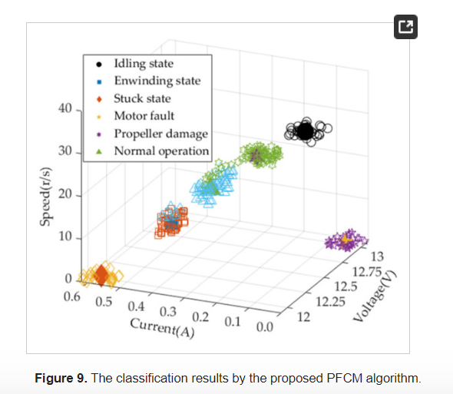

The paper titled “[Design and Construction of an](https://www.sciencedirect.com/science/article/pii/S0925231214005219?casa_token=HGXFoyBWJjEAAAAA:GCAEEa4G6BlrRHodkBBrXueNIu01c9goeieNLUeUWdysdw4eldWUmRj8ocfS0lHPBP2vMtFB4nc) Autonomous Underwater Vehicle”, written by [K Alam](https://scholar.google.com/citations?user=0x5L2RMAAAAJ&hl=en&oi=sra), [T Ray](https://scholar.google.com/citations?user=16ms6e0AAAAJ&hl=en&oi=sra), and [SG Anavatti](https://scholar.google.com/citations?user=qz90ea4AAAAJ&hl=en&oi=sra) highlights that AUVs are gaining popularity for ocean exploration, military, and industrial applications, particularly for underwater search and survey operations due to their cost-effectiveness compared to manned vehicles. Previous AUV designs have focused on functionality rather than identifying optimum designs.

1. Optimization Algorithms used: The paper utilizes two state-of-the-art population-based optimization algorithms, namely the non-dominated sorting genetic algorithm (NSGA-II) and the infeasibility-driven evolutionary algorithm (IDEA). These algorithms are written in Matlab and integrated with CATIA using VBScript to automate the entire AUV design process.
2. Usage of Algorithms and Benefits: The optimization algorithms employed in this study are formulated to minimize the objective functions of the problem, and a negative sign is placed to maximize the length of the lever arm in Formulation 2. The use of population-based stochastic optimization algorithms, such as NSGA-II and IDEA, is preferred over conventional local search approaches due to the highly constrained nature of the problem.
3. Goal of the Framework: The framework is used to identify the optimal design of a torpedo-shaped AUV with an overall length of 1.3 m. The designed AUV is further analyzed using the computer-aided design tool CATIA to generate a detailed design.
4. Design of AUVs: The proposed optimization framework offers full multidisciplinary design optimization functionalities for AUVs and provides advantages over traditional functional design approaches. The framework allows the designer to incorporate additional modules and control the complexity of the optimization problem definition. The commercial CFD software package ANSYS 13.0 is used to simulate the flow around the designed AUVs.
5. Conclusion: The key aspects of the proposed framework are the ability to represent various torpedo-shaped AUV geometries, the design generated while considering clash-free internal arrangement and effects of external shape, the seamless integration of Matlab and CATIA, and in-house performance analysis codes, the ability to solve various forms of single and multi-objective, constrained formulation of the AUV design problems based on user requirements.

The rest of the paper is organized into sections describing the proposed optimization framework, numerical experiments, results, and a summary of the study's findings.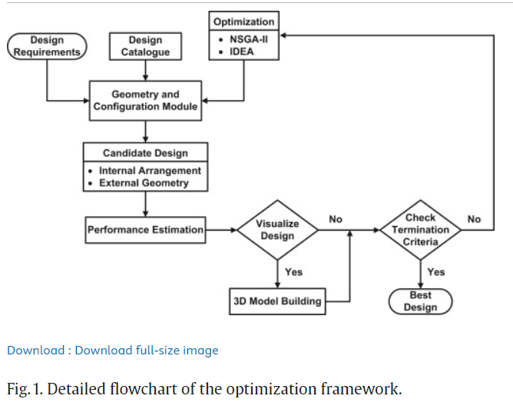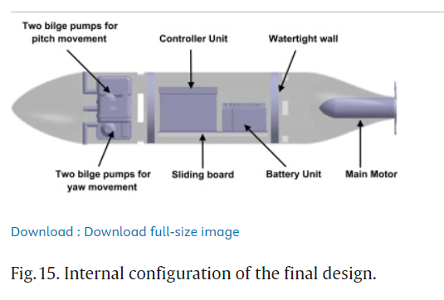

Written by [J Yuh](https://scholar.google.com/citations?user=t4R9KUwAAAAJ&hl=en&oi=sra), SK Choi, C Ikehara, GH Kim, the paper “[Design of a Semi-autonomous Underwater Vehicle for Intervention Missions (SAUVIM)](https://ieeexplore.ieee.org/abstract/document/670059/)” discusses the design and development of a Semi-Autonomous Underwater Vehicle for Intervention Missions (SAUVIM). Current underwater vehicles used for intervention missions are either manned submersibles or remotely operated vehicles (ROVs) with manipulators, which are expensive and face safety issues. The proposed SAUVIM aims to address these limitations and improve intervention capabilities in terms of autonomy, cost-effectiveness, and performance.

1. Introduction to SAUVIMs: The SAUVIM is a pioneer autonomous underwater vehicle with a fully functioning manipulator and the capability for human intervention in operation monitoring, verification, and correction. The vehicle is designed to improve underwater intervention capabilities in terms of autonomy, cost-effectiveness, and performance. It aims to perform intervention tasks such as underwater plug-in/plug-out, construction and repair, cable streaming, mine hunting, munitions retrieval, and scientific data gathering.
2. Design of SAUVIMs: The SAUVIM is equipped with a multiprocessor configuration for adaptive, intelligent motion planning and predictive virtual environment monitoring. It utilizes a genetic algorithm method for route optimization and has a mission sensor package for obtaining scientific data during vehicle cruising and at the workspace. The mission sensor package includes sensors for recording water pressure, temperature, conductivity, salinity, dissolved oxygen, pH, turbidity, and magnetic signature of the seafloor.
3. Discussed Methods: The paper mentions the use of Computational Fluid Dynamics (CFD) methods for drag analysis and optimization of the fairing shape of the SAUVIM. A 2-dimensional analysis of the fairing using the commercial CFD package PHOENICS has been conducted, indicating the potential benefits of these methods. A 3-dimensional analysis of the fairing is also planned.
4. Validation of Model: Experiments on a prototype fairing will be conducted to validate the results and conclusions of the CFD analysis. The path planning system of the SAUVIM is based on a genetic algorithm (GA) method for optimizing the vehicle's route.
5. Conclusions: The SAUVIM will allow human intervention from a land-based computer system capable of vehicle path planning and monitoring. The SAUVIM base computer system includes a multiprocessor configuration with a Silicon Graphics Onyx workstation and several Pentium PC computers.

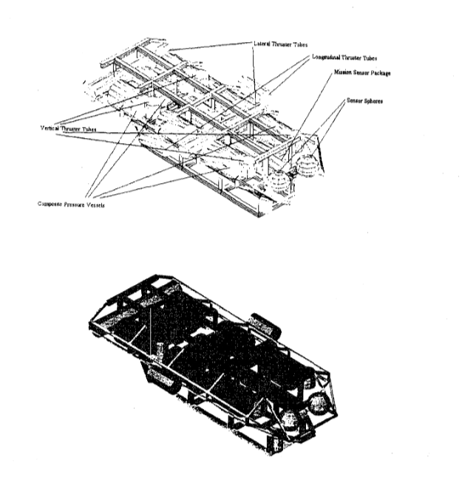

The paper titled "Design and Simulation of an Autonomous Underwater Vehicle" focuses on the development of an AUV called "Tifone" for the monitoring of underwater archaeological sites. The research is part of the Thesaurus project, funded by Regione Toscana.

1. Introduction to Tifoen: The vehicle is designed to carry out a customizable payload according to different mission profiles, with a maximum operative depth of 300 m, a maximum speed of 5 knots, and an autonomy of more than 8 hours. The control system of the vehicle is based on lateral and vertical thrusters to ensure high maneuverability and stability at cruise speed.
2. Design: The paper focuses on two different control strategies corresponding to the different mission profiles the vehicle can perform. The vehicle is designed with specific technical requirements, including a maximum operative depth of 300 m, a maximum speed of 5 knots, and an autonomy of more than 8 hours. The control system of the vehicle is based on lateral and vertical thrusters to ensure high maneuverability and stability at cruise speed.
3. Methods used: The desired trajectory generation and the development of a control system are discussed, including the use of a PID controller with proportional, integral, and derivative components. The paper mentions the use of gravity compensation for stability, especially when the dynamic model of the vehicle is known.
4. Conclusion: The paper presents the design and simulation of an Autonomous Underwater Vehicle (AUV) called "Tifone" for the monitoring of underwater archaeological sites. Particularly in this paper, the control strategy of the vehicle is described.

The vehicle has six propellers and its control strategy was developed after 17 Benedetto Allotta, Riccardo Costanzi, Niccolo Monni, Luca Pugi, Alessandro Ridolfi, and Gregorio Vettori's first phase concerning the study of its dynamic behavior and the analysis of its hydrodynamic response, through CFD simulations. As soon as the vehicle is ready, a huge experimental campaign will be performed inside the MDM Lab in Pistoia (Italy) and in the Tuscany Sea.

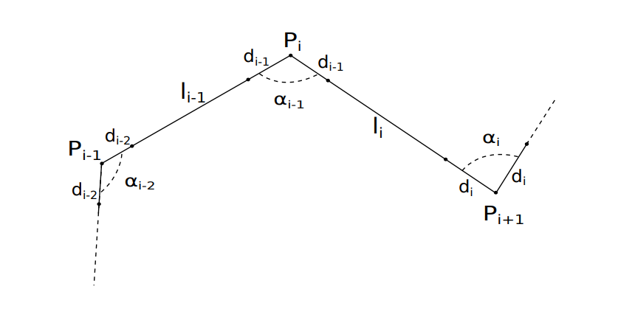

The paper, “Absolute Positioning of an Autonomous Underwater Vehicle Using GPS and Acoustic Measurements”, written by Neil H. Kussat, C. David Chadwell, and Richard Zimmerman discuss the use of kinematic GPS positioning and underwater acoustic ranging to locate an autonomous underwater vehicle (AUV) with an accuracy of 30 cm in the global International Terrestrial Reference Frame 2000 (ITRF2000).

1. Pre-requisites: Autonomous underwater vehicles (AUVs) provide marine researchers with new forms of access to the ocean, serving as platforms for various sensors such as acoustic, magnetic, gravimetric, and chemical sensors. A key requirement for AUVs is accurate navigation and localization, particularly for mapping seafloor bathymetry and detecting seafloor changes over time.
2. Methods Used: The authors establish an array of three precision transponders on the seafloor, with each transponder's horizontal position determined with an accuracy of 8 cm using two-way travel times measured with microsecond resolution.
3. Results: Simulations show that replacing the time-difference approach with directly measured two-way travel times between the AUV and seafloor transponders can achieve 30 cm absolute positioning of the AUV.
4. Discussions: The paper mentions that the submeter absolute positioning of underwater vehicles in water depths up to several thousand meters is practical, with the limiting factor being knowledge of near-surface sound speed. The paper also mentioned the use of a precision long-baseline (LBL) system, where the AUV position is determined relative to seafloor transponders, known in an absolute frame with subdecimeter precision.
5. Affecting Factors: The accuracy of AUV positioning is affected by factors such as knowledge of near-surface sound speed, which can degrade the precision of transponder placement in the ITRF2000 frame.

The paper concluded an AUV horizontal position accuracy of 2m was achieved using globally referenced seafloor transponders and a time-difference mode which met the requirements of the synthetic aperture experiment. Using this actual data error source validation, a simulation shows that 30 cm horizontal position uncertainty is possible by measuring direct travel times to seafloor transponders that are known in the global frame. Using geodetic quality GPS measurements to position a shipboard antenna array and carefully transferring these positions to the shipboard transducer permits 8 cm uncertainty in locating seafloor transponders in shallow water (m).

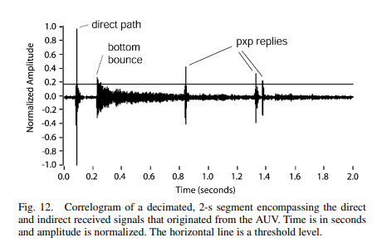

The paper, “Autonomous Underwater Vehicles for Ocean Exploration” by Justin E. Manley discusses the role of Autonomous Underwater Vehicles (AUVs) in ocean exploration, highlighting their importance in commercial, military, and scientific sectors. The NOAA Office of Ocean Exploration (OE) recognizes AUVs as an important component of its research and operational programs.

The oceans and great inland seas are considered as the remaining frontiers of human discovery, and ocean exploration has the potential to yield valuable information about the origins of life and new resources. Recent technological advancements have enabled new initiatives in ocean exploration, with potential economic, archaeological, health, and quality of life benefits.

1. Introduction: The paper describes the current and envisioned operational use of AUVs in exploration, emphasizing their potential benefits in discovering important information about the origins of life on earth and new resources. AUVs are recognized as well-suited for marine archaeology, particularly in deep water where there may be many undiscovered sites of interest.
2. Areas of Focus: OE's primary focus is exploring the very deep ocean, including trenches beyond 10,000 meters, which distinguishes it from most oceanographic programs. OE aims to leverage its limited budget for the greatest impact by focusing on pilot projects with limited budgets and developing partnerships with other agencies interested in advanced technology.
3. Conclusion: The paper emphasizes the need for expanded mapping of the seafloor, particularly in the deep ocean, to prioritize further exploratory or research missions . The OE program aims to leverage its limited budget by focusing on pilot projects and developing partnerships with other agencies interested in advanced technology. The potential benefits of ocean exploration, enabled by AUVs and advanced technology, include economic, archaeological, health, and quality of life advancements.

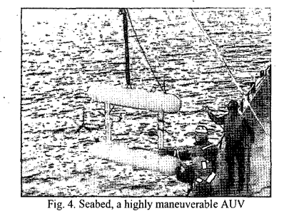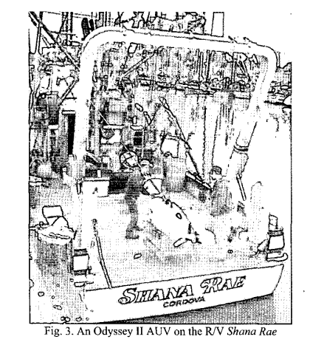

Limitations:

1. No explicit discussion of the limitations of the research or the proposed design of the Semi-Autonomous Underwater Vehicle for Intervention Missions (SAUVIM)
2. No mention of specific details about the research methods used in the study
3. The papers do not explicitly state the limitations of the research or any potential biases that may have influenced the findings
4. The papers do not discuss any potential challenges or limitations associated with the use of Autonomous Underwater Vehicles (AUVs) in ocean exploration
5. No discussion or mention of any potential limitations or constraints related to the budget or resources available for the research and development of AUVs
6. The papers do not provide a comprehensive analysis of the current state of AUV technology or any potential limitations or areas for improvement in AUV capabilities
7. The paper does not discuss any potential limitations or sources of error in the simulations conducted to estimate the absolute positioning accuracy of the AUV

Suggested Future Works:

1. Introducing a 3D path planner and testing the capability of AUVs in a 3D environment.
2. Implementing the water current effect on the AUV and see how the vehicle is behaving because of it and how it is trying to track its trajectory
3. Develop the dynamic model by taking an asymmetric design, where the CG and CB are not at the center of the vehicle, and observe whether it is controlling its instability.
4. Build an actual AUV model, analyze the simulator data with a physical model, and validate the utility of the AUV simulator
5. Exploration of different trajectory generation methods and control system approaches for the vehicle, depending on the specific mission requirements and conditions
6. The performance of path planning algorithms is always closely related to the physical limitations of AUVs in practical applications, so it is also necessary to take them into account in future work
7. Generate the optimal paths for multi-AUV in the realistic ocean environment, such as strong currents fields, irregularly shaped terrains, and uncertain dynamic obstacles

# 

# **Methodology**

Graph Theory

Graph theory is the study of graphs, which are mathematical structures that represent a particular function by connecting a set of points. It is used to create a pairwise relationship between objects. Formally, a graph is denoted as a pair G(V, E), where V represents the finite set vertices and E represents the finite set edges.

Therefore, we can say a graph includes a non-empty set of vertices V and a set of edges E.

* MATLAB- MATLAB is used to analyze and design the systems and products transforming built-in graphics to make it easy to visualize and gain insights from data. It helps us to-
* Design, model, and simulate autonomous system scenarios that include platforms, trajectories, paths, sensors, using various coordinate systems, maps.
* Generate and classify detections, estimate platforms, and obtain various maps of the environment.
* Plan the paths of robots, UAVs, and automobiles using different path-planning algorithms based on varied motion characteristics.
* Control robots, UAVs, and automobiles using multiple motion control algorithms and strategies.
* Connect to robots and simulators through middleware (e.g. ROS) and deploy your designed estimation, navigation, and control algorithms on hardware.

Eg.- Creating driving Scenario Interactively and Generate Synthetic Sensor Data

Object Tracking and Motion Planning Using Frenet Reference Path

Numerical Integration

Integration is the process of finding the area of the region under the curve. This is done by drawing as many small rectangles covering up the area and summing up their areas. The sum approaches a limit that is equal to the region under the curve of a function. Integration is the process of finding the antiderivative of a function. If a function is integrable and if its integral over the domain is finite, with the limits specified, then it is a definite integration. The basic problem in numerical integration is to compute an approximate solution to a definite integral.

$$\int_{a}^{b}{}f(x) dx$$

* Runge-Kutta Method- It is used to solve differential equations. These give us higher accuracy without performing more calculations. One of the most significant advantages of Runge-Kutaa formulae is that it requires the function’s values at some specified points. It is used to solve the differential equations governing the AUV's dynamics

Consider an ordinary differential equation of the form dy/dx = f(x, y) with initial condition y(x0) = y0. For this, we can define the formulas for Runge-Kutta methods as follows.

* 1st Order Runge-Kutta method-

y1 = y0 + hf(x0, y0) = y0 + hy’0 {since y’ = f(x, y)}

* 2nd Order Runge-Kutta method

y1 = y0 + (½) (k1 + k2)

Here, k1 = hf(x0, y0), k2 = hf(x0 + h, y0 + k1)

* 3rd Order Runge-Kutta method

y1 = y0 + (⅙) (k1 + 4k2 + k3)

Here, k1 = hf(x0, y0), k2 = hf[x0 + (½)h, y0 + (½)k1], k3 = hf(x0 + h, y0 + k1) such that k1 = hf(x0 + h, y0 + k1)

Hydrodynamic Modeling

* Buoyancy and Hydrostatics-
* Buoyancy Force: Buoyancy is the upward force exerted on an object immersed in a fluid, such as water, due to the difference in pressure between the top and bottom of the object. It represents the vehicle's ability to float and maintain a specific depth.
* Hydrostatic Pressure: Hydrostatic pressure refers to the pressure exerted by a fluid at equilibrium due to the force of gravity. It helps simulate its behavior in different water depths and pressures.
* Drag and Resistance-
* Drag Coefficients: Drag is the resistance force experienced by an AUV as it moves through water. It depends on factors such as the AUV's shape, surface roughness, and speed relative to the water.
* Resistance Forces: Resistance forces arise due to the interaction between the AUV and the water. These forces include skin friction drag, form drag (pressure drag), and wave-making drag.
* Added Mass Effects-
* Added Mass: Added mass refers to the increase in apparent mass experienced by an AUV due to the surrounding water's inertia. This phenomenon affects the AUV's dynamic response to accelerations and decelerations.

Six Degrees of Freedom (6-DOF) Dynamics

* Dynamic Equations:
* Translation Motion: The AUV's translational motion in six degrees of freedom (surge, sway, heave) is described by Newton's second law, where the net forces acting on the vehicle determine its acceleration.
* Rotation Motion: The AUV's rotational motion (roll, pitch, yaw) is described by Euler's equations of motion, which relate the angular accelerations to the net torques acting on the vehicle.
* External Forces and Torques:
* Hydrodynamic Forces and Torques: Hydrodynamic forces, including buoyancy, drag, and added mass effects, contribute to the net forces and torques acting on the AUV.
* Control Inputs: Control inputs, such as thruster commands or control surface deflections, can also generate forces and torques that affect the AUV's motion.

# **Algorithm**

DynamicSimulation_Of_AUVs():

Input:

Current, Temperature, Fluid_density, Position, Velocity, Mass, Simulation_time_total, Simulation_step, Position_obstacle, Collision_flag

Output:

AUV trajectory, Collision detection

Declaration:

Current Float (m/sec) x1

Temperature Float (°C) x2

Fluid_density Float (kg/m3) ρ

Position Float (m) (dx, dy, dz)

Velocity Float (m/sec) v1

Mass Float (kg) m

Simulation_time_total Integer (sec) t1

Simulation_step Integer (sec) t2

Position_obstacle Float (m) (px, py, pz)

Collision_flag Integer i

Procedure:

For t2=0: t1; t2<=t1; t2++

Update x1

Translation motion:

Fdrag ​= ½⋅C​⋅ρ⋅A⋅v1

Fdrag= drag force

C= drag coefficient

A= cross-sectional area perpendicular to the flow

Fbuoyancy​ = ρ​⋅g⋅Vdisplaced

​Fbuoyancy= buoyancy force

g= gravitational acceleration

Vdisplaced= volume of fluid displaced

Fgravity ​= m⋅g

Fgravity= gravity force

g= gravitational acceleration

F = Fdrag+Fbouyancy+Fgravity

F= total force on AUV

a = F/m

a= acceleration of AUV

v1 = v1 + a.t2

dx = dx + v1.t2

dy= dy + v1.t2

dz= dz + v1.t2

Rotation motion:

Ix = (y2 + z2).dm

Iy = (x2 + z2).dm

Iz = (y2 + x2).dm

x, y, z= distances from roll axis to mass elements

Ix = Lnet

Iy = Mnet

Iz = Nnet

Ix​= moment of inertia of the AUV about the roll axis

Iy​= moment of inertia of the AUV about the pitch axis

Iz= moment of inertia of the AUV about the yaw axis

ϕ= roll angle

θ= pitch angle

ψ= yaw angle

Lnet= net torque acting on the AUV about the roll axis

Mnet= net torque acting on the AUV about the pitch axis

Nnet= net torque acting on the AUV about the yaw axis

Collision detection:

If dx = px:

i++

If dy = py:

i++

If dz = pz:

i++

End for

Result:

If the value of the variable Collision_flag, i, increases, collision between the obstacle and the underwater vehicle will be there. This also gives the trajectory of the vehicle.

# **Implementation**

Code:

#include <stdio.h>

// Function to calculate the integral using the trapezoidal rule

float integrate(float x[], float y[], int n) {

float sum = 0;

for (int i = 1; i < n; i++) {

sum += (y[i - 1] + y[i]) * (x[i] - x[i - 1]) / 2.0;

}

return sum;

}

void DynamicSimulation_Of_AUVs(float x1, float x2, float fluid_density,

float position[3], float velocity, float mass,

int simulation_time_total, int simulation_step,

float position_obstacle[3], int *collision_flag) {

float dx = position[0];

float dy = position[1];

float dz = position[2];

float v1 = velocity;

float g = 9.81; // gravitational acceleration

float C = 0.5; // drag coefficient

float A = 1.0; // cross-sectional area perpendicular to the flow

float a; // acceleration

float px = position_obstacle[0];

float py = position_obstacle[1];

float pz = position_obstacle[2];

int t1 = simulation_time_total;

int t2 = simulation_step;

float Fdrag, Fbuoyancy, Fgravity, F;

float Ix, Iy, Iz;

float Lnet, Mnet, Nnet;

for (int i = 0; i <= t1; i += t2) {

// Update current

printf("Enter value of current:");

scanf("%f", &x1);

// Translation motion

Fdrag = 0.5 * C * fluid_density * A * v1 * v1;

Fbuoyancy = fluid_density * g * mass;

Fgravity = mass * g;

F = Fdrag + Fbuoyancy + Fgravity;

a = F / mass;

v1 = v1 + a * t2;

dx = dx + v1 * t2;

dy = dy + v1 * t2;

dz = dz + v1 * t2;

// Rotation motion

float x[] = {dx, dy, dz}; // Distance from roll axis to mass elements

float y[] = {dx * dx + dy * dy, dy * dy + dz * dz, dx * dx + dz * dz}; // Integrand

Ix = integrate(x, y, 3);

Iy = integrate(x, y, 3);

Iz = integrate(x, y, 3);

// Collision detection

if (dx == px || dy == py || dz == pz) {

*collision_flag += 1;

}

}

// Print final results

printf("Final acceleration: %.2f m/s^2\n", a);

printf("Final velocity: %.2f m/s\n", v1);

printf("Final position (dx, dy, dz): %.2f, %.2f, %.2f\n", dx, dy, dz);

}

int main() {

float x1 = 0.0; // Current (m/sec)

float x2; // Temperature (°C)

float fluid_density = 1000.0; // Fluid density (kg/m^3)

float position[3] = {0.0, 0.0, 0.0}; // Initial position (m)

float velocity; // Initial velocity (m/sec)

float mass = 100.0; // Mass (kg)

int simulation_time_total; // Total simulation time (sec)

int simulation_step = 1; // Simulation time step (sec)

float position_obstacle[3] = {10.0, 10.0, 10.0}; // Position of the obstacle (m)

int collision_flag = 0; // Collision flag

printf("Enter temperature:\n");

scanf("%f", &x2);

printf("Enter total simulation time in seconds:\n");

scanf("%d", &simulation_time_total);

printf("Enter initial velocity of AUV:\n");

scanf("%f", &velocity);

DynamicSimulation_Of_AUVs(x1, x2, fluid_density, position, velocity, mass,

simulation_time_total, simulation_step,

position_obstacle, &collision_flag);

if (collision_flag > 0) {

printf("Collision detected!\n");

} else {

printf("No collision detected.\n");

}

return 0;

}

Result:

Collision Detection Outcome: The value of the collision flag indicates whether a collision occurred between the AUV and the obstacle. Additionally, the trajectory of the AUV is captured during the simulation.

This algorithm provides a comprehensive framework for simulating the motion of AUVs in underwater environments, considering both translational and rotational dynamics. It provides valuable insights into the AUV's behavior over time and helps detect potential collisions with obstacles underwater.

# **References and Citations**

1. Liang, X., Zhang, J., Qin, Y., & Yang, H. (2013). Dynamic Modeling and Computer Simulation for Autonomous Underwater Vehicles with Fins. Journal of Computers, 8(4).

<https://doi.org/10.4304/jcp.8.4.1058-1064>

1. Al‐Bzoor, M., Al‐assem, E., Alawneh, L., & Jararweh, Y. (2021). Autonomous underwater vehicles support for enhanced performance in the Internet of Underwater Things. Transactions on Emerging Telecommunications Technologies, 32(3). [https://doi.org/10.1002/ett.4225‌](https://doi.org/10.1002/ett.4225)
2. Zhuang, Y., Huang, H., Sharma, S., Xu, D., & Zhang, Q. (2019). Cooperative Path Planning Of Multiple Autonomous Underwater Vehicles Operating In Dynamic Ocean Environment. *ISA Transactions*, *94*, 174–186. <https://doi.org/10.1016/j.isatra.2019.04.012>
3. Elmokadem, T., Zribi, M., & Youcef-Toumi, K. (2018). Control for Dynamic Positioning and Way-point Tracking of Underactuated Autonomous Underwater Vehicles Using Sliding Mode Control. Journal of Intelligent & Robotic Systems, 95(3-4), 1113–1132.

<https://doi.org/10.1007/s10846-018-0830-8>

1. Gan, W., Su, L., & Chu, Z. (2023). A PSO-enhanced Gauss pseudospectral method to solve trajectory planning for autonomous underwater vehicles. Mathematical Biosciences and Engineering, 20(7), 11713–11731. [https://doi.org/10.3934/mbe.2023521‌](https://doi.org/10.3934/mbe.2023521%E2%80%8C)
2. Sun, Z., Yu, J., Zhang, A., Huang, Y., & Wang, Z. (2019). Design and Characteristic Analysis of Variable Buoyancy System for Long Range Autonomous Underwater Vehicle.

<https://doi.org/10.1145/3351917.3351973>

1. Liu, Y., Che, J., Xu, H., & Cao, C. (2015). Adaptive Attitude Control of Autonomous Underwater Vehicles Using Back-stepping.

[https://doi.org/10.1145/2831296.2831343‌](https://doi.org/10.1145/2831296.2831343%E2%80%8C)

1. Gan, W., Su, L., & Chu, Z. (2023). Trajectory Planning of Autonomous Underwater Vehicles Based on Gauss Pseudospectral Method. Sensors, 23(4), 2350.<https://doi.org/10.3390/s23042350>
2. Tian, Q., Wang, T., Liu, B., & Ran, G. (2022). Thruster Fault Diagnostics and Fault Tolerant Control for Autonomous Underwater Vehicle with Ocean Currents. Machines, 10(7), 582.

<https://doi.org/10.3390/machines10070582>

1. Alam, K., Ray, T., & Anavatti, S. G. (2014). Design and construction of an autonomous underwater vehicle. Neurocomputing, 142, 16–29. <https://doi.org/10.1016/j.neucom.2013.12.055>
2. Design of a semi-autonomous underwater vehicle for intervention missions (SAUVIM). (1998). IEEE Conference Publication | IEEE Xplore. <https://ieeexplore.ieee.org/stamp/stamp.jsp?tp=&arnumber=670059>
3. Design and Simulation of an Autonomous Underwater Vehicle by [B Allotta](https://scholar.google.com/citations?user=8IHsm_cAAAAJ&hl=en&oi=sra), [R Costanzi](https://scholar.google.com/citations?user=C4z8fEYAAAAJ&hl=en&oi=sra), N Monni, [L Pugi](https://scholar.google.com/citations?user=nSqzq0AAAAAJ&hl=en&oi=sra), [A Ridolfi](https://scholar.google.com/citations?user=ZuZrRTMAAAAJ&hl=en&oi=sra), G Vettori et al. (2012)

<https://d1wqtxts1xzle7.cloudfront.net/41631406/Design_and_Simulation_of_an_Autonomous_U20160127-16059-xmxzi0-libre.pdf?1453899516=&response-content-disposition=inline%3B+filename%3DDesign_and_simulation_of_an_autonomous_u.pdf&Expires=1708887299&Signature=NLXv9asH0aXwIYmMtbtDFuXyl4EG17hMOi2WLzxesrR-7~dUpSADxrbpyjhcwMXpoSdsAIXhq6Xg5c5C3AGrLguzJeD8iUPaj6Ac78J4TUF2lnRQGBA1MuIL900H~Vh4d2m~GW93HKosgfP1U5~D81IkogPrHbtlsQ2y2cnbF~G3KzMUTSz0tGWy56aMMNi5LXIgiX14oT16FUIyUqR2jHy78sFw4bDIZdDaH238qLCmcX8t0OXe3GETn-5FC-P7khxwy2OwHS0iwfpq0gQaFl4~R6--Ptrl78J523nBASEAtDJebgW6eGLMitobpkZrx44wdrPn52MOOfA5kUQvXw__&Key-Pair-Id=APKAJLOHF5GGSLRBV4ZA>

1. Absolute positioning of an autonomous underwater vehicle using GPS and acoustic measurements. (2005, January 1). IEEE Journals & Magazine | IEEE Xplore. <https://ieeexplore.ieee.org/stamp/stamp.jsp?tp=&arnumber=1435583>
2. Autonomous underwater vehicles for Ocean Exploration. (2003). IEEE Conference Publication | IEEE Xplore. <https://ieeexplore.ieee.org/stamp/stamp.jsp?tp=&arnumber=1282454>
3. Zhang, X., Yang, F., Liu, H., Zhang, Y., & Sha, Q. (2023). Design and implementation of autonomous underwater vehicle simulation System based on MOOS and Unreal Engine. *Electronics*, *12*(14), 3107.

<https://doi.org/10.3390/electronics12143107>

1. Yang, Y., Xiao, Y., & Li, T. (2021). A survey of autonomous underwater vehicle formation: performance, formation control, and communication capability. In IEEE, IEEE COMMUNICATIONS SURVEYS & TUTORIALS (Vol. 23, Issue 2, pp. 815–816).

<https://doi.org/10.1109/COMST.2021.3059998>

1. Vasudev, K. L. (2020). Review of autonomous underwater vehicles. In IntechOpen eBooks.

<https://doi.org/10.5772/intechopen.81217>

1. Alam, T., Newaz, A. a. R., Bobadilla, L., Al-Sabban, W. H., Smith, R. N., & Karimoddini, A. (2021). Towards Energy-Aware feedback Planning for Long-Range Autonomous Underwater vehicles. Frontiers in Robotics and AI, 8. <https://doi.org/10.3389/frobt.2021.621820>
2. Design process and advanced manufacturing of an aquatic surface vehicle Hull for the integration of a hydrogen power plant propulsion system. - Free online library. (n.d.). [https://www.thefreelibrary.com/Design+Process+and+Advanced+Manufacturing+of+an+Aquatic+Surface. . .-a0784041402](https://www.thefreelibrary.com/Design+Process+and+Advanced+Manufacturing+of+an+Aquatic+Surface)
3. Ali, O. H. a. G. S. F. F. a. S., & Ali, O. H. a. G. S. F. F. a. S. (2023). Unmanned underwater vehicles: applications and challenges. <http://jonuns.com/index.php/journal/article/view/1491/1483>
4. Abbasi, S., Zeinali, M., & Nejadabbasi, P. (2018). Autonomous underwater vehicle hull geometry optimization using a multi-objective algorithm approach. <https://www.semanticscholar.org/paper/Autonomous-Underwater-Vehicle-Hull-Geometry-Using-a-Abbasi-Zeinali/2c18a9b4f721d39062a61af3cef53d0e981f19e6>
5. Anwar, I., Mohsin, M., Iqbal, S., Abideen, Z., Rehman, A., & Ahmed, N. (2016). Design and fabrication of an underwater remotely operated vehicle (Single thruster configuration). <https://www.semanticscholar.org/paper/Design-and-fabrication-of-an-underwater-remotely-Anwar-Mohsin/4b51f5cbb6fd2ab871372c83fd7c7b2f28644158>
6. Riedel, J., Healey, A., Marco, D., & Beyazay, B. (2005). Design and development of low cost variable buoyancy system for the soft grounding of autonomous underwater vehicles. <https://www.semanticscholar.org/paper/Design-and-Development-of-Low-Cost-Variable-System-Riedel-Healey/4aa09e6cd94d6bd1c72b872a410d54ade4b2ddad>
7. Sahoo, A., Dwivedy, S. K., & Robi, P. S. (2019). Advancements in the field of autonomous underwater vehicle. Ocean Engineering, 181, 145–160. <https://doi.org/10.1016/j.oceaneng.2019.04.011>
8. Leonard, J. J., & Bähr, A. (2016). Autonomous underwater vehicle navigation. In Springer eBooks (pp. 341–358).

<https://doi.org/10.1007/978-3-319-16649-0_14>

1. Seaglider: a long-range autonomous underwater vehicle for oceanographic research. (2001, October 1). IEEE Journals & Magazine | IEEE Xplore. <https://ieeexplore.ieee.org/abstract/document/972073/?casa_token=fEn1nBbyBjEAAAAA:NGnvEOV5d5WeDNMiUYXoQWQFyVwLSF8d9tP-ZAXvFejuLZYw7yC_igNxH8865vFKhrl4snppMdR5>
2. Hyakudome, T. (2011). Design of autonomous underwater vehicle. International Journal of Advanced Robotic Systems, 8(1), 9.

<https://doi.org/10.5772/10536>

1. Autonomous underwater vehicle navigation. (2010, July 1). IEEE Journals & Magazine | IEEE Xplore. <https://ieeexplore.ieee.org/abstract/document/5546885?casa_token=Sag3Y66b1lUAAAAA:U8szMZQYjWoWnqkkdJbm_41qsD9l4pyDTMODY6I2nEcqEr7c9kmYXc6U9I6japAo3MxiExLjX7dp>
2. Cohan, S. (2008). Trends in ROV development. In Marine Technology Society, Marine Technology Society Journal.

<https://doi.org/10.4031/002533208786861335>

1. Defense Technical Information Center. (n.d.). <https://apps.dtic.mil/sti/citations/tr/ADA286833>
2. Control architectures for autonomous underwater vehicles. (1997, December 1). IEEE Journals & Magazine | IEEE Xplore. <https://ieeexplore.ieee.org/abstract/document/642974?casa_token=5Z0s9wgLzFsAAAAA:oJ2L9n3qvNxl-lj0lPfz2gk8hhX3qFws3niANIDXFlYmxPpCuCbHU-NVbnGS_z1ffzciB2RY4WBi>
3. Bovio, E., Cecchi, D., & Baralli, F. (2006). Autonomous underwater vehicles for scientific and naval operations. Annual Reviews in Control, 30(2), 117–130. <https://doi.org/10.1016/j.arcontrol.2006.08.003>
4. Modeling and simulation of autonomous underwater vehicles: design and implementation. (2003, April 1). IEEE Journals & Magazine | IEEE Xplore. <https://ieeexplore.ieee.org/abstract/document/1209627?casa_token=SPBt1HmkvSAAAAAA:1wOA3kQtszQcqM5dDdrXbdWxoCPmJZSfoCNrGznWosA4xNHu_pKQ1fCvTdt1tbtEFQKqVuEVC7MC>
5. Evans, J., & Nahon, M. (2004). Dynamics modeling and performance evaluation of an autonomous underwater vehicle. Ocean Engineering, 31(14–15), 1835–1858. <https://doi.org/10.1016/j.oceaneng.2004.02.006>
6. Absolute positioning of an autonomous underwater vehicle using GPS and acoustic measurements. (2005b, January 1). IEEE Journals & Magazine | IEEE Xplore. <https://ieeexplore.ieee.org/abstract/document/1435583?casa_token=vj3tmm0EnbYAAAAA:0ZUNDjaKX67Gb3YBeM8v0Prxc_zdHm_V1ydrM-A1FiYimEpIOJ-ufFbUNgK_CPnECQySKKmQfM4Y>
7. Path planning for autonomous underwater vehicles. (2007, April 1). IEEE Journals & Magazine | IEEE Xplore. <https://ieeexplore.ieee.org/abstract/document/4154833?casa_token=7Rxt0oTH52cAAAAA:iDsv0mE-9DZRPgUG3Nk7xNa6qoPx746w9knqqxkBSZhLON1tYlKYhKcDru648JpUNOznTrxj5nnv>
8. Navigation technologies for autonomous underwater vehicles. (2008, July 1). IEEE Journals & Magazine | IEEE Xplore. <https://ieeexplore.ieee.org/abstract/document/4524846?casa_token=IxwYoyIRRNQAAAAA:EP0pJuj-rz2DRibqPx5CqlJywljqdCjDxrUOExG1VmqonxDdytFuWF7gKA9jB6laP_3bujPgAb6M>
9. Lin, Y., Hsiung, J., Piersall, R., White, C. F., Lowe, C. G., & Clark, C. M. (2016). A Multi‐Autonomous underwater vehicle system for autonomous tracking of marine life. Journal of Field Robotics, 34(4), 757–774.

<https://doi.org/10.1002/rob.21668>

1. Kumar, G., Painumgal, U. V., Kumar, M., & Rajesh, K. (2018). Autonomous underwater vehicle for vision based tracking. Procedia Computer Science, 133, 169–180.

<https://doi.org/10.1016/j.procs.2018.07.021>

1. Informative path planning for an autonomous underwater vehicle. (2010, May 1). IEEE Conference Publication | IEEE Xplore. <https://ieeexplore.ieee.org/abstract/document/5509714?casa_token=C-p2rnnOCNQAAAAA:gvbwjMjeFyb85PnJWRPshqrgvKYzp6-GFKlAyzHs2BuLUpDzXXXffC-AWCwOw39FEoo52DH1esJy>